HONOR
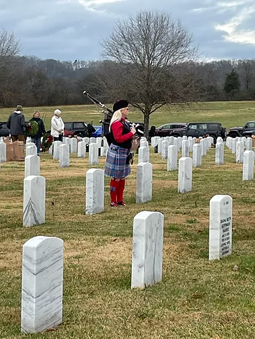

Incorporated by an act of congress in 1937,
the Marine Corps League perpetuates the traditions and spirit of ALL Marines who
proudly wear or who have worn the eagle, globe, and anchor of the Corps

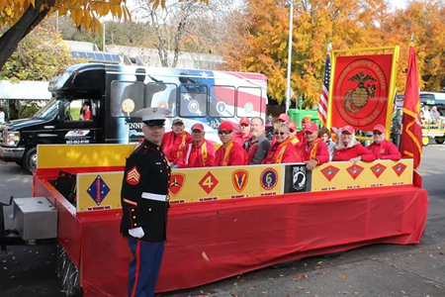
THE FEW
COURAGE
SERVING OUR COMMUNITY
- SCHOLARSHIP PROGRAM
To Provide Scholarship Grants to those who are pursuing their first undergraduate degree and are enrolled as a full-time student in an accredited college or university. For detachment members and their direct family; active duty and drilling reservists (Marines and FMF Corpsmen); children of KIA Marines, FMF Corpsmen and Chaplains residing within the geographic boundaries of our detachment.

- MILITARY HONORS
It is our privilege to provide full military honors to our fallen comrades expressing dignity and respect
To hold sacred the history and memory of those who have given their lives to our nation

- EDUCATING
Providing education of our nation’s military and patriotic heritage
To perpetuate the history of the Marine Corps and observe the historical occasions of our Corps

- TOYS FOR TOTS
Continuing the tradition of ensuring that less fortunate children enjoy a little Christmas

- VETERAN ASSISTANCE
Offering a helping hand to our fellow veterans as well as to their families

- SUPPORTING VETERAN CAUSES
We help make veterans causes successful through our active involvement and financial assistance

- CAMARADERIE AND FELLOWSHIP

- YOUNG MARINES PROGRAM
National youth program for boys and girls, ages eight through high school graduation, focused on leadership, citizenship through community service, self-discipline, and living a healthy, drug-free lifestyle.

- MARINE CORPS LEAGUE AUXILLARY
To preserve the traditions and to promote the
interests of the United States Marine Corps.
To maintain true allegiance to American institutions.
​
THE PROUD
COMMITTMENT
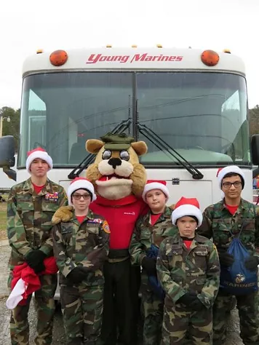
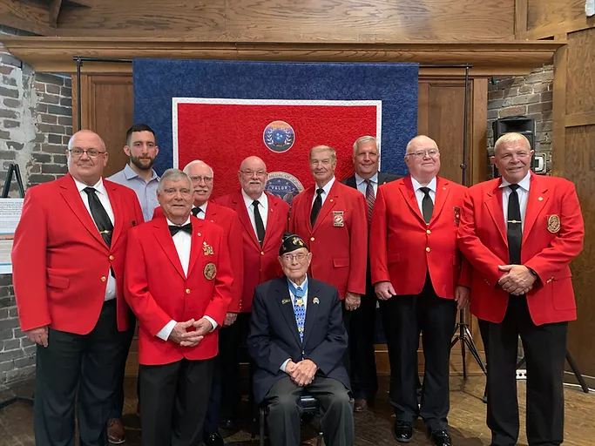
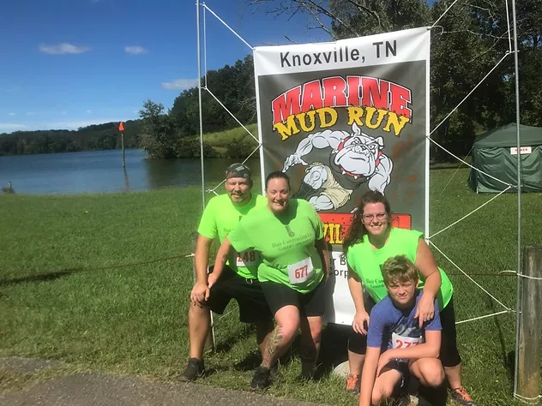
THE MARINES
Mission Statement:
The Marine Corps League perpetuates the traditions and spirit of ALL Marines and Navy FMF Corpsmen, who proudly wear or who have worn the eagle, globe, and anchor of the Corps. It takes great pride in crediting its founding in 1923 to World War I hero, then Major General Commandant John A. Lejeune. It takes equal pride in its Federal Charter, approved by An Act of the Seventy-Fifth Congress of the United States of America and signed and approved by President Franklin D. Roosevelt on August 4, 1937. The League is the only Federally Chartered Marine Corps related veteran’s organization in the country. It is a not-for-profit organization within the provisions of the Internal Revenue Service Code 501(c) (4), with a special group exemption letter which allows for contributions to the Marine Corps League, its Auxiliary and subsidiary units, to be tax deductible by the donor.
MARINE CORPS LEAGUE
LT. ALEXANDER BONNYMAN DETACHMENT #924
PO BOX 53293 ▪ KNOXVILLE, TN.
37950-3293
Meetings held on last Tuesday of each
month (except December) at
VFW POST 5154 ▪ 2561 HOBBS RD.
LOUISVILLE, TN. 37777
1730-1830: Social Hour
1830-1930: Meeting
www.mclknoxville.org
Contact us at:
Info@MCLKnoxville.org
SEMPER FIDELIS
APPLICATION FOR MEMBERSHIP
(Full size application is on MCLKnoxville.org, INFO tab)
FULL NAME_______________________________________________________
STREET___________________________________________________________
CITY_________________________STATE________________ZIP_____________
PHONE (___)__________________EMAIL________________________________
DATE OF BIRTH_____/_____/______
DATE OF ENLISTMENT/COMMISSION____________________________________
DATE OF DISHARGE/ SEPERATION/RETIREMENT___________________________
SSN# OR SERVICE # _______________________________________________
TYPE OF APPLICATION—NEW ( ) RENEWAL ( ) DUAL ( )
ASSOCIATE ( ) REGULAR ( )
HAVE YOU EVER BEEN CONVICTED OF A FELONY? ( ) YES ( ) NO IF YES IS CHECKED, I AGREE TO WAIVE MY RIGHTS UNDER THE PRIVACY ACT AND DISCLOSE THE NATURE OF THE FELONY CONVICTION FOR CONSIDERATION OF MEMBERSHIP IN THE MARINE CORPS LEAGUE.
( ) I AGREE TO PROVIDE A CORRECT COPY OF MY DD214
( ) I HEREBY APPLY FOR MEMBERSHIP IN THE ________________ DETACHMENT, MARINE CORPS LEAGUE AND ENCLOSE $________FOR ONE YEAR’S MEMBERSHIP.
( ) I HEREBY APPLY FOR MEMBERSHIP IN THE MARINE CORPS LEAGUE AS A MEMBER-AT LARGE (MAL) AND ENCLOSE $_______ FOR ONE YEAR’S MEMBERSHIP.
I HEREBY CERTIFY THAT I AM CURRENTLY SERVING OR HAVE SERVED HONORABLY IN THE U.S. MARINE CORPS, ON ACTIVE DUTY, FOR NOT LESS THAN NINETY (90) DAYS* OR HAVE SERVCED OR AM CURRENTLY SERVING IN THE U.S. MARINE CORPS RESERVE AND HAVE EARNED NO LESS THAN NINETY (90) RESERVE RETIREMENT CREDIT POINTS OR THAT I HAVE SERVED OR AM CURRENTLY SERVING AS A U.S. NAVY CORPSMAN WHO HAS TRAINED WITH MARINE FMF UNITS IN EXCESS OF NINETY (90) DAYS AND EARNED THE MARINE CORPS DEVICE OR WARFARE DEVICE WORN ON THE SERVICE RIBBON AUTHORIZED FOR FMF CORPSMEN; OR HAVE SERVED OR ARE CURRENTLY SERVING AS A U.S. NAVY CHAPLAIN AND HAVE EARNED THE FMF BADGE SERVING WITH MARINES; . IF DISCHARGED, I AM IN RECEIPT OF AN HONORABLE DISHARGE OR DD214. BY SIGNATURE ON THIS APPLICATION, I HEREBY AGREE TO PROVIDE PROOF OF HONORABLE SERVICE/DISCHARGE UPON REQUEST. I HEREBY AUTHORIZE THE NATIONAL EXECUTIVE DIRECTOR, MARINE CORPS LEAGUE TO OBTAIN AN UN-REDACTED COPY OF MY LATEST DD FORM 214 FROM THE MARINE CORPS CUSTODIAN OF OFFICIAL MILITARY PERSONNEL FILES (OMPF), AND/OR VERIFICATION OF HONORABLE SERVICE IF DEEMED NECESSARY TO VERIFY MY ELIGIBILITY FOR REGULAR MEMBERSHIP IN THE MARINE CORPS LEAGUE. I UNDERSTAND THE DD FORM 214 MAY CONTAIN INFORMATION SUCH AS MILITARY AWARDS, TRAINING, AND CHARACTER OF SERVICE.

______________________________ _____________________________________
(SPONSOR NAME IF APPLICABLE) APPLICANT’S SIGNATURE
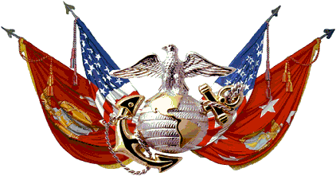

LT. ALEXANDER BONNYMAN
DETACHMENT #924
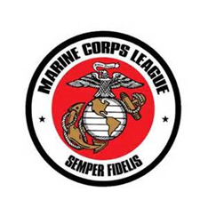

We few, we precious few.
We who have shed our blood
Together, shall forever be…
….A BAND OF BROTHERS
W. Shakespeare

